General Instructions to Prepare Synopsis

Spine of the Synopsis | The spine of the synopsis must be followed by the title of the synopsis in the following manner:
Paper size | International standard paper size A4 (297 x 210 mm).
Typing | On one side of the paper only.
Margins | Margins - left-3.0cm, Right-2.0 cm, Top-2.5 cm, Bottom-2.5 cm, Gutter-0
For Main Text | - Font type: Times New Roman  - Font size: 12 points  Line spacing: 1.5 Lines  Character spacing: Normal
For Foot Notes | - Font type: Same as the main text (Times New Roman)  - Font size: 10 points.  Line spacing: Single
Page Numbering | - Page numbering should be in continuation from ABSTRACT to the last.

VOICE GENDER RECOGNITION USING MACHINE LEARNING



A Synopsis Report Submitted to

SAGE University, Indore
towards Partial fulfillment for the award of B.Tech

degree with specialization in Artificial Intelligence in Computer Science Engineering

JAN-JUNE 2024

Guided by Submitted by

Dr. Sachin Patel Shreya Sihare [21ADV3ARI0012]
Prof. Sneha Padiyal

Department of Computer Science and Engineering
Institute of IET-IAC
www.sageuniversity.in
Approval Sheet

The project entitled “VOICE GENDER RECOGNITION USING MACHINE LEARNING” submitted by Shreya Sihare approved as partial fulfillment for the award of the B.Tech degree by SAGE University, Indore.

(Student Name & Sign) (Guide Name & Sign)

Name : Shreya Sihare Dr. Sachin Patel
Sign : Sign :

Prof. Sneha Padiyal

Date: 23/04/2024 Date: 23/04/2024

Project Coordinator
Name : Prof. Kuntal Barua
Sign :

Table of Contents

S. No |  | Page No
1 | Abstract
2 | Introduction
3 | Objective of Project
4 | Research gap identified
5 | Frontend technology
6 | Backend end technology
7 | System Requirements
8 | Features
9 | Proposed Methodology
10 | Implementation
11 | Results
12 | Testing and Analysis
13 | Applications
14 | Future Scope
15 | Conclusion
16 | Details of Project Outcome
17 | References

Abstract

Voice gender recognition, a fundamental task in speech processing, involves determining the gender of a speaker based solely on their vocal characteristics. This paper presents a comprehensive study on voice gender recognition using traditional machine learning techniques. Leveraging a diverse dataset of voice samples, we explore the efficacy of K-Nearest Neighbors, Naive Bayes, Decision Tree, Random Forest, XG Boost, Support Vector Machine and Neural Network in accurately classifying gender from voice signals.

Our approach involves a meticulous feature engineering process, where we extract and select discriminative features from voice recordings. These features encapsulate gender-specific information embedded within the acoustic properties of speech. Through extensive experimentation, we evaluate the performance of each machine learning algorithm, considering metrics such as accuracy, precision, recall and F-1 score.

The field of voice analysis by providing insights into the feasibility and efficacy of traditional machine learning techniques for voice gender recognition. The findings have practical implications across various domains, including speech-based authentication systems, gender-aware customer interactions, and sociolinguistic research.

1
Introduction

In the realm of speech processing and artificial intelligence, the ability to discern gender from voice signals has emerged as a fascinating and practical endeavor. Voice gender recognition, a subset of speaker recognition, involves the classification of speakers into male or female categories based solely on their vocal characteristics. This task holds significant importance in various domains, including but not limited to human-computer interaction, forensics, and sociolinguistics.

Traditionally, voice gender recognition relied heavily on manual feature engineering and classical machine learning algorithms to extract discriminative features from voice samples and make accurate gender predictions. However, recent advancements in machine learning have paved the way for more automated and data-driven approaches, offering the potential for
improved accuracy and robustness.

Voice gender recognition using machine learning techniques, aiming to explore the effectiveness of various algorithms in accurately classifying gender from voice signals. By leveraging a diverse dataset comprising voice recordings from speakers of different genders, we seek to analyze the performance of different machine learning models, including K-Nearest Neighbors, Naive Bayes, Decision Tree, Random Forest, XG Boost, Support Vector Machine and Neural Network.

Our approach involves several key steps, including preprocessing, visualizing, model training, and performance evaluation, thereby enhancing the efficiency and accuracy of the model. In preprocessing we used Label Encoder to normalize labels, and then visualize the data, and then we use most significant features Q25, IQR and meanfun. And then we used algorithms for training and testing of the model and find the highest accuracy of the model.

2
Objective of Project

The objective of voice gender recognition using machine learning is to develop algorithms and models capable of accurately determining the gender of a speaker based solely on their voice characteristics.

This field employs various techniques from machine learning, signal processing, and pattern recognition to extract relevant features from audio samples and classify them into male or female categories. By leveraging large datasets of labeled voice samples, these models can learn to identify subtle nuances in pitch, tone, and other acoustic attributes associated with gender.

The ultimate goal is to create robust and reliable systems that can be deployed in various applications, such as speech-based interfaces, customer service, and security systems, to enhance user experience and facilitate more personalized interactions.

3
Research gap identified for this proposed project

One research gap in voice gender recognition using machine learning is the limited exploration of multi-modal data fusion techniques. While traditional approaches primarily focus on analyzing acoustic features extracted from voice samples, there is a growing recognition of the potential benefits of integrating additional modalities, such as facial expressions or linguistic features, to improve classification accuracy and robustness.

Research has shown that combining information from multiple modalities can provide complementary cues and enhance the discriminative power of gender recognition systems. For example, facial expressions captured from video recordings could convey additional gender-related information, while linguistic features extracted from speech transcripts could offer insights into language usage patterns associated with gender.

However, the exploration of multi-modal data fusion techniques in voice gender recognition remains relatively underexplored. There is a lack of comprehensive studies that systematically investigate the integration of different modalities, assess their relative contributions, and develop effective fusion strategies to leverage the complementary nature of the information.

4
Minimum System Requirements

For voice gender recognition using machine learning, the minimum system requirements depend on various factors, including the complexity of the machine learning models, the size of the dataset, and the desired level of performance. At a basic level, a computer with a modern CPU, sufficient RAM, and storage capacity is necessary for data processing, model training, and inference.

For smaller-scale experiments and prototyping, a computer with an Intel Core i5 or AMD Ryzen 5 processor, 8GB of RAM, and 256GB of storage would suffice. However, for larger datasets and more computationally intensive models, a more powerful CPU, such as an Intel Core i7 or AMD Ryzen 7, and 16GB or more of RAM may be required to handle the increased computational workload effectively.

In terms of software requirements, a programming environment such as Python with libraries like NumPy, Pandas, Scikit-learn, and TensorFlow or PyTorch for deep learning would be essential for data preprocessing, model development, and evaluation. Additionally, access to GPU resources, either through a dedicated GPU or cloud-based services like Google Colab or AWS Sage maker, can significantly accelerate model training and inference for deep learning-based approaches.

While the minimum system requirements outlined above provide a baseline for conducting voice gender recognition experiments, it's important to note that the specific requirements may vary depending on the complexity of the project and the available resources. As such, researchers and practitioners should consider factors such as dataset size, model architecture, and computational constraints when determining the system requirements for their voice gender recognition tasks.

5
Features/ Characteristics

Voice gender recognition using machine learning relies on a variety of features and characteristics extracted from voice signals to accurately classify the gender of speakers. One key feature is pitch, which refers to the fundamental frequency of the voice and often exhibits distinct differences between male and female speakers.

Additionally, formants, which represent resonant frequencies in the vocal tract, contribute valuable information about vocal tract length and shape, aiding in gender classification. Spectral characteristics, such as energy distribution across different frequency bands, can also be informative, as male and female voices tend to exhibit differences in spectral profiles. Temporal patterns, including speech rate, rhythm, and intonation, further contribute to gender classification by capturing subtle variations in speech production.

Moreover, linguistic cues, such as vocabulary choice and language style, may also play a role in distinguishing between male and female speakers. By leveraging these features and characteristics, machine learning models can effectively capture gender-related variations in voice signals and make accurate predictions, paving the way for applications in authentication, virtual assistance, sociolinguistic research, and beyond. Continued research and refinement of feature extraction methods are essential to enhance the performance and adaptability of voice gender recognition systems across diverse demographics and contexts.

6
Proposed Methodology

- Data Collection and Preprocessing:
  - Gather a diverse dataset of voice recordings, including samples from male and female speakers representing various demographics, accents, and languages.
  - Preprocess the audio data to ensure consistency and quality, including normalization of audio levels, removal of noise, and segmentation into smaller, manageable segments.
- Feature Extraction:
  - Extract relevant acoustic features from the preprocessed voice recordings. Common features include pitch, formants, Mel-frequency cepstral coefficients (MFCCs), and spectral characteristics.
  - Consider applying signal processing techniques such as Fourier transform or wavelet transform to extract additional features that capture unique aspects of the voice signal.
- Dataset Splitting and Encoding:
  - Split the dataset into training, validation, and testing sets to facilitate model training, validation, and evaluation.
  - Encode the gender labels (e.g., male as 0, female as 1) to prepare them for training the machine learning model.
- Model Selection and Training:
  - Explore a variety of machine learning algorithms suitable for classification tasks, such as K-nearest Neighbour, Support Vector Machine, Neural Network, Naïve Bayes, Decision Tree, XG Boost, and Random Forest.
  - Train multiple models using the training dataset and fine-tune hyperparameters using techniques such as grid search or random search to optimize performance.
- Model Evaluation:
  - Evaluate the trained models on the validation dataset using appropriate performance metrics such as accuracy, precision, recall, and F1-score.

7
  - Select the best-performing model based on validation results and further validate its performance on the testing dataset to assess its generalization capability.
- Interpretability and Analysis:
  - Conduct feature importance analysis to identify the most discriminative features for gender recognition.
  - Visualize decision boundaries and misclassifications to gain insights into the model's behavior and potential areas for improvement.
- Deployment and Integration:
  - Deploy the trained machine learning model as part of a voice gender recognition system, integrating it into real-world applications such as voice-based authentication systems, virtual assistants, or voice-controlled devices.
  - Implement monitoring and maintenance procedures to ensure the continued performance and reliability of the deployed model in production environments.

8
Implementation

Implementing voice gender recognition using machine learning involves several key steps, including data collection, preprocessing, visualizing, feature extraction, model development, and evaluation.

First, a diverse dataset of voice recordings is collected, encompassing speakers of different genders, ages, accents, and languages. The data is then preprocessed to remove noise, normalize audio levels, and extract relevant features such as pitch, formants, and spectral characteristics.

Next, machine learning models are developed to classify the gender of speakers based on the extracted features. Various algorithms such as K-Nearest Neighbors, Naive Bayes, Decision Tree, Random Forest, XG Boost, Support Vector Machine and Neural Network may be explored and trained on the preprocessed data.

Once trained, the models are evaluated using performance metrics such as accuracy, precision, recall and F-1 score on a separate test dataset to assess their effectiveness and generalization capabilities.Throughout the implementation process, considerations for scalability, computational efficiency, and interpretability are essential. Additionally, optimizations such as hyperparameter tuning, cross-validation, and model ensembling may be employed to improve model performance further.

Finally, the trained models are deployed in real-world applications, such as voice-based authentication systems, virtual assistants, or sociolinguistic research tools, where they can provide valuable insights into gender differences in speech patterns and enhance user experiences. Regular updates and maintenance are crucial to ensure the continued effectiveness and relevance of the deployed models.

9
Results
In Voice Gender Recognition System we used Machine Learning algorithms such as K-nearest Neighbour, Naive Bayes, Decision Tree, Random Forest, XG Boost, Support Vector Machine and Neural Network in which can see that the highest accurracy is 98.74% which is made by XgBoost.

10
Testing and Analysis

We have applied machine learning algorithms such as, K-Nearest Neighbors, Naive Bayes, Decision Tree, Random Forest, XG Boost, Support Vector Machine and Neural Network in our model, in which the highest accuracy has been given by XG Boost. We also analyzed that we have also reduced the error rate by applying algorithms. These are some graphs of reducing error rate.

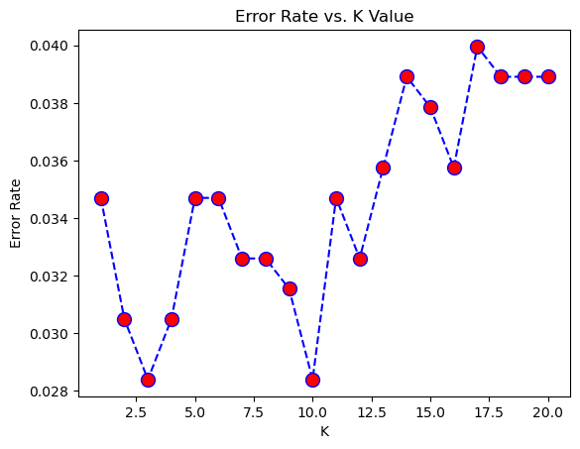

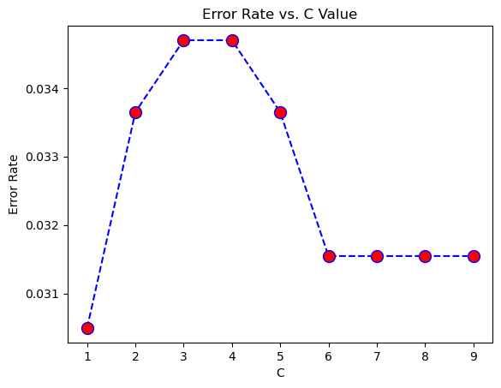

11
Applications

Voice gender recognition using machine learning has numerous applications across various domains. Here are some notable examples:

- Voice-Based Authentication Systems: Voice gender recognition can be utilized as part of voice biometric systems for authentication and identification purposes. By determining the gender of a speaker, these systems can enhance security measures for access control in smartphones, banking applications, and other secure platforms.

- Gender-Aware Virtual Assistants: Virtual assistants such as Siri, Alexa, and Google Assistant can personalize their responses and interactions based on the perceived gender of the user. Voice gender recognition enables these assistants to adapt their language, tone, and responses to better suit the preferences and needs of users, enhancing user experience and engagement.

- Market Research and Customer Analytics: Voice gender recognition can be employed in market research and customer analytics to gather insights into consumer demographics and preferences. By analyzing the gender distribution of voice interactions in call centers, surveys, and customer service platforms, businesses can tailor their marketing strategies and product offerings to target specific demographic groups more effectively.

- Sociolinguistic Studies: Voice gender recognition facilitates sociolinguistic research examining gender differences in speech patterns and language use. Researchers can analyze large datasets of voice recordings to investigate linguistic phenomena related to gender, such as pitch variation, speech rate, intonation patterns, and vocabulary choices, providing valuable insights into sociocultural factors influencing language behavior.

12
Future Scope

In the evolving landscape of machine learning and voice technology, the future scope for voice gender recognition holds immense potential for innovation and advancement. As research continues to push the boundaries of machine learning techniques, there are several promising avenues for further development. One key direction lies in improving the accuracy and robustness of voice gender recognition models through the exploration of advanced algorithms and feature engineering methods. Deep learning architectures such as convolutional neural networks (CNNs) and recurrent neural networks (RNNs) offer opportunities to automatically extract hierarchical representations of voice features, enhancing model performance across diverse datasets and conditions. Additionally, there is a growing need to adapt voice gender recognition systems to diverse demographic groups, considering factors such as culture, age, and language. Developing culturally sensitive and inclusive models requires collecting representative datasets and employing domain adaptation techniques to mitigate biases and ensure fairness. Furthermore, the integration of voice gender recognition with other modalities, such as facial expressions and contextual information, opens up new possibilities for multimodal fusion and context-aware modeling, enhancing the reliability and relevance of gender classification in real-world applications. As voice technology continues to evolve, addressing ethical and societal implications, including privacy, fairness, and consent, will be crucial to ensuring the responsible development and deployment of voice gender recognition systems. Overall, the future of voice gender recognition using machine learning is characterized by opportunities for innovation, inclusivity, and ethical considerations, paving the way for transformative applications across diverse domains.

13

Conclusion

In conclusion, voice gender recognition using machine learning stands at the forefront of technological innovation, offering a range of applications and opportunities for advancement. Through the utilization of diverse datasets and sophisticated machine learning algorithms, significant progress has been made in accurately classifying gender from voice signals.

The exploration of advanced techniques such as deep learning architectures and multimodal fusion holds promise for further improving the accuracy, robustness, and adaptability of gender recognition systems. However, as this field continues to evolve, it is essential to address ethical and societal considerations, including privacy, fairness, and transparency, to ensure the responsible development and deployment of these technologies.

By prioritizing inclusivity, fairness, and user consent, voice gender recognition can empower diverse communities and contribute to the creation of more equitable and accessible voice-based applications. Looking ahead, continued research and collaboration across disciplines will be vital in unlocking the full potential of voice gender recognition and harnessing its benefits for society.

14

References

https://www.kaggle.com/code/donghaoqiao/gender-recognition-by-voice-with-python

https://ijisrt.com/assets/upload/files/IJISRT23MAY1247.pdf

https://iopscience.iop.org/article/10.1088/1757-899X/263/4/042084/pdf

15

